

Celebrating Adults in Higher Education

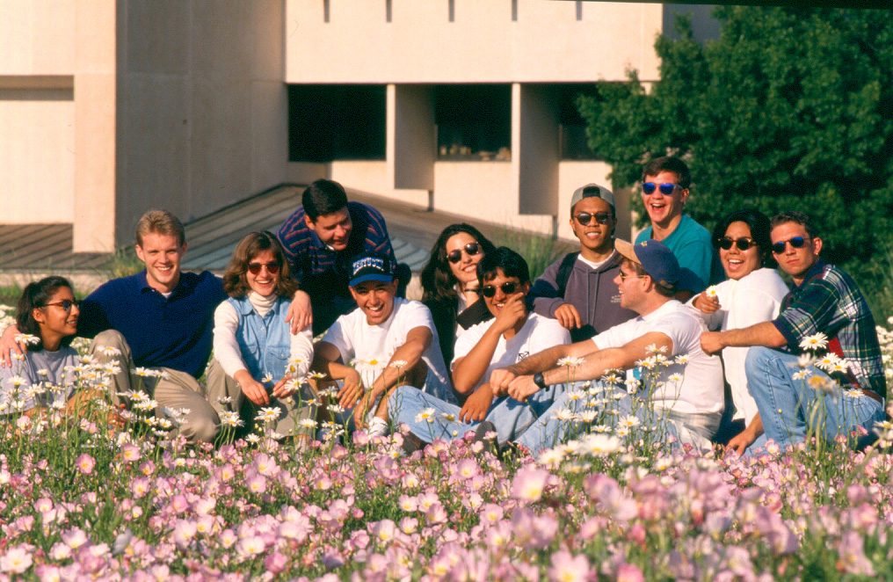

National ANTSHE Conference
Dallas, Texas

Hosted by
The University of Texas at Dallas
March 19-21, 2004

Return Registration form to:

University of Texas at Dallas
Julie Evans – MP14
P.O. Box 830688
Richardson, Texas 75083-0688
Or FAX to:
Julie Evans 972-883-6808
(Beginning January 22, 2004)

Conference Hotel Reservations
http://www.radisson.com/antshe

Questions?
mineje@utdallas.edu

Conference Registration

Dr. ___ Mr. ___ Mrs. ___ Ms. ___
Name: _____________________________
Institution/Organization _______________
Address: ____________________________
City: ______________________________
State: ________ ZIP Code: ____________
Contact Number: _____________________
FAX Number: _______________________
E-Mail Address: _____________________

Registration Type and Fees

Student Member………..$75 _________
Student Non Member…..$90 _________
Member………………...$190 _________
Non Member…………...$250 _________

Please indicate here if you will need vegetarian meals __________

******************************
ANTSHE Membership and Fees

Student………………….$10 _________
Alumnus or Alumni…….$20 _________
Academic Professional…$50 __________
Friend…………………..$50 _________
Institutional…………….$250 _________
Organizational………….$250 _________

Side Trips – Your Choice $26
(Please indicate your selection)

___1) West End Historic District – Individuals can enjoy several different night clubs and a choice of eateries. The West End also features a four level shopping mall great for collecting souvenirs and such.

____2) Galleria Shopping Mall – One of the best malls in the Dallas area. Features over 200 stores, food courts and an Ice Skating rink ($9 for skating and skate rental)
Side trips MUST be pre-paid
******************************
Payment

Total Amount of Payment ____________
Check ______Visa ____ Mastercard _____
Credit Card Number: __________________
Name on Card: ______________________
Cardholders Signature: ________________

